♀24. Death (Burnout)—Track 28 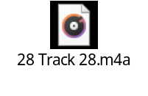
Abell 39 is an ancient planetary nebula that has been spreading out for thousands of years. It now stretches six light-years across. Whatever violence it knew in its early years is long forgotten. The cloud is so diffuse that distant galaxies can be seen through it. Astronomers once would have called the orderly, spherical Abell 39 a textbook example of a planetary nebula—but the Hubble Space Telescope has forced scientists to rewrite the textbooks.
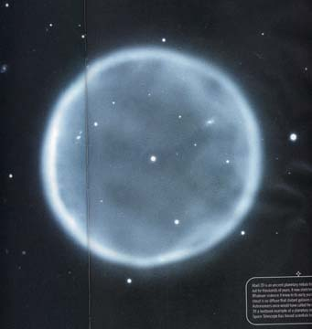

Time, even astronomical time, is made of moments. The universe began in a moment around 13.7 billion years ago. The sun was born in a moment some 4.6 billion years ago, when hydrogen atoms began fusing into helium. At another moment, some 5 billion years from now, the sun will exhaust its fuel and begin a slow death. Somewhere in the Milky Way galaxy, a star like our sun dies roughly every month. When that happens, it briefly exhales an extraordinarily beautiful, complex puff of gas known as a planetary nebula.
